**An adiabatic process** occurs without transfer of [heat](https://en.wikipedia.org/wiki/Heat) or [mass](https://en.wikipedia.org/wiki/Mass) of substances between a [thermodynamic system](https://en.wikipedia.org/wiki/Thermodynamic_system) and its surroundings. In an adiabatic process, energy is transferred to the surroundings only as [work](https://en.wikipedia.org/wiki/Work_(thermodynamics)).

**A plume of smoke,** dust, fire, or water is a large quantity of it that rises into the air in a column. The rising **plume** of black **smoke** could be seen all over Kabul.

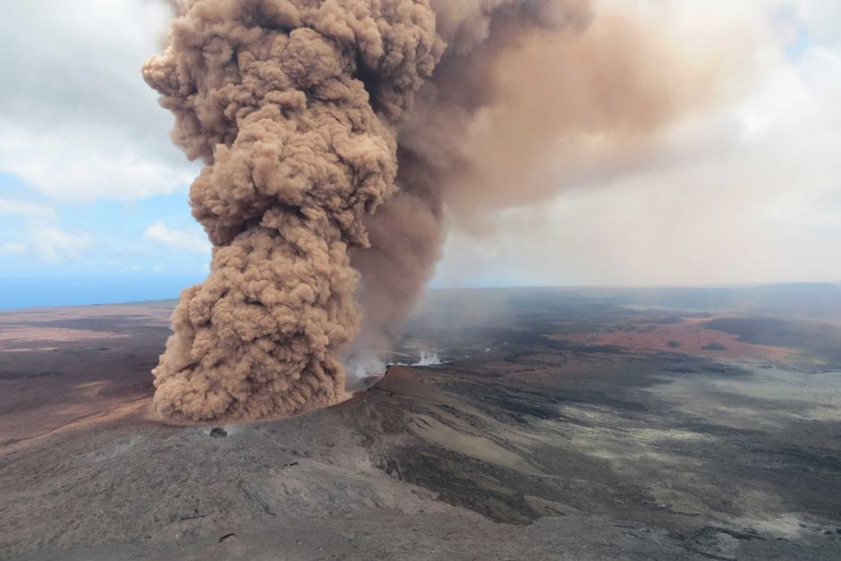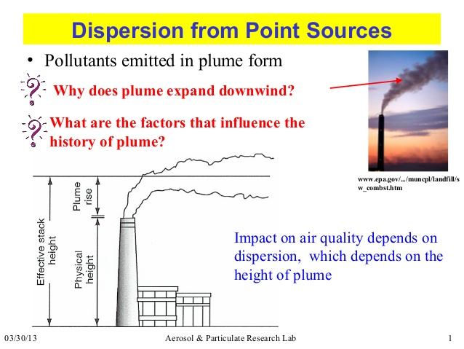

**Dander** is material shed from the body of humans and animals that have fur, hair, or feathers. Pet **dander** is composed of tiny, even microscopic, flecks of skin shed by cats, dogs, rodents, birds and other animals with fur or feathers. These bits of skin can cause reactions in people who are specifically **allergic** to these triggers. Additional allergy triggers or allergens come from sources other than the animal's skin. Proteins found in saliva, urine and feces from cats, dogs and other pets can cause allergic reactions in some people.

**Differences Between Varnish and Lacquer**

Both varnish and lacquer provide shiny and [glossy finishes](https://www.doityourself.com/stry/terms-of-the-trade-what-is-polyurethane-varnish) to furniture and fixture surfaces. While lacquers can come in clear or a colored coating, varnishes tend to be completely transparent and are rarely produced in any other color.

Whilst the process of application is similar, varnish is usually brushed on while lacquer is normally sprayed on. One of the main differences between varnish and lacquer is that the latter is much quicker to dry. [Lacquer](https://www.doityourself.com/stry/different-types-of-lacquer-finishes), due to its evaporating solvents, will always dry on a surface much quicker than varnish. As lacquer is naturally glossier than varnish, one coat is usually sufficient, while varnish may require several coats.

**Dendrite**:

**Adhesive** makes it possible to stick mirrors, laces, ribbons, sequins, appliqué, beads, cords, seams, foil and glitter dust etc. to various kinds of fabric quickly and effortlessly.

**An aldehyde** is a compound containing a functional group with the structure −CHO, consisting of a carbonyl center (a carbon double-bonded to oxygen) with the carbon atom also bonded to hydrogen and to an R group, which is any generic alkyl or side chain

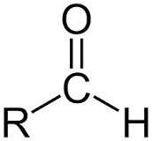

**Acrolein** (systematic name: propenal) is the simplest unsaturated aldehyde. It is a colourless liquid with a piercing, acrid smell. The smell of burnt fat (as when cooking oil is heated to its smoke point) is caused by glycerol in the burning fat breaking down into **acrolein**.

Acrolein is toxic and is a strong irritant for the skin, eyes, and nasal passages.

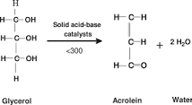

**Formaldehyde** is a simple chemical compound made of hydrogen, oxygen and carbon.

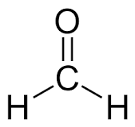

Aside from ALS risk or other nervous system consequences, **formaldehyde** is a respiratory irritant that causes chest pain, shortness of breath, coughing, and nose and throat irritation, according to the ATSDR. It can also cause cancer, and has been linked to an increased risk of asthma and allergies in kids.

**Legionella** is a pathogenic group of Gram-negative bacteria that includes the species L. pneumophila, causing **legionellosis** (all illnesses caused by **Legionella**) including a pneumonia-type illness called Legionnaires' disease and a mild flu-like illness called Pontiac fever.

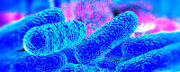

**Staphylococcus aureus** is a Gram-positive, round-shaped bacterium that is a member of the Firmicutes, and it is a usual member of the microbiota of the body, frequently found in the upper respiratory tract and on the skin.

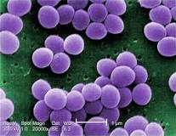

Commonly **found** on the skin and hair as well as in the noses and throats of people and animals. These bacteria are **present** in up to 25 percent of healthy people and are even more common among those with skin, eye, nose, or throat infections.

**Staphylococcus aureus** (MRSA) skin infections start out as small red bumps that can quickly turn into deep, painful abscesses.

* Nausea and vomiting.
* Diarrhea.
* Dehydration.
* Low blood pressure.

**Asbestos** is a term used to refer to six naturally occurring silicate minerals. All are composed of long and thin fibrous crystals; each **fiber** being composed of many microscopic 'fibrils' that can be released into the atmosphere by abrasion and other processes.

Asbestos is an excellent [**electrical insulator**](https://en.wikipedia.org/wiki/Electrical_insulator) and is **highly resistant to heat**, so for many years it was used as a building material. However, it is a well-known [health hazard](https://en.wikipedia.org/wiki/Health_hazard), and today its use as a building material is banned in many countries. Inhalation of asbestos fibers can lead to various serious lung conditions, including [asbestosis](https://en.wikipedia.org/wiki/Asbestosis) and [cancer](https://en.wikipedia.org/wiki/Cancer).

**Drowsiness**: a feeling of being sleepy and lethargic

**Fabric softener** is a [conditioner](https://en.wikipedia.org/wiki/Conditioner_(chemistry)) that is typically applied to [laundry](https://en.wikipedia.org/wiki/Laundry) during the rinse cycle in a [washing machine](https://en.wikipedia.org/wiki/Washing_machine). As with soaps and detergents, fabric softeners may cause [irritant dermatitis](https://en.wikipedia.org/wiki/Irritant_dermatitis).  Fabric softener overuse may make clothes more [flammable](https://en.wikipedia.org/wiki/Flammable), due to **the fat-based nature of most softeners.**

**Deodorize**: to eliminate or prevent the offensive odor of.

**Photochemical oxidants** ***are the product of chemical reactions*** that occur between nitrogen oxide (NO) and any of a host of different volatile organic compounds (VOCs). Common or well-known photochemical oxidants include ozone (O3), hydrogen peroxide (H2O2), and peroxyacetyl nitrate (PAN).

**Ketone** bodies are the water-soluble molecules containing the ketone group that are produced by the liver from fatty acids during periods of low food intake, carbohydrate restrictive diets, starvation, prolonged intense exercise, alcoholism, or in untreated type 1 diabetes mellitus.

Functional group with the structure RC(=O)R', where R and R' can be a variety of carbon-containing substituents.

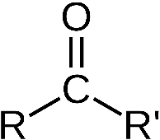

**Plasticizers:** A substance (typically a solvent) added to a synthetic resin to produce or promote plasticity and flexibility and to reduce brittleness.

**Binder:** A **binder** or **binding agent** is any material or substance that holds or draws other materials together to form a cohesive whole mechanically, chemically, by [adhesion](https://en.wikipedia.org/wiki/Adhesion) or [cohesion](https://en.wikipedia.org/wiki/Cohesion_(chemistry)).

In a narrower sense, binders are liquid or dough-like substances that harden by a chemical or physical process and bind fibers, filler powder and other particles added into it. Examples include [glue](https://en.wikipedia.org/wiki/Glue), [adhesive](https://en.wikipedia.org/wiki/Adhesive) and [thickening](https://en.wikipedia.org/wiki/Thickening).

**Resin:** It isa sticky flammable organic substance, insoluble in water, extracted by some trees and other plants. It is valued for its chemical constituents and uses, such as basis components of plastics, varnishes, adhesives or other products and as an important source of raw materials for organic synthesis, or for incense and perfume. They are also used for coatings on paper, particleboard, and other surfaces that require a decorative, protective, or special-purpose finish.

**Formaldehyde** is used in making **resins** such as **urea-formaldehyde** that are used in adhesives for some composite wood products (particle board, fiberboard, and plywood) used to manufacture furniture. Formaldehyde is found in some paints, lacquers, and coatings used to manufacture wood furniture.

Formaldehyde is a highly toxic systemic poison that is absorbed well by inhalation. The vapor is a severe respiratory tract and skin irritant and may cause dizziness or suffocation. ... Skin Protection: Chemical-protective clothing is recommended because formaldehyde can cause skin irritation and burns.

Formaldehyde is also a byproduct of combustion. When burning natural gas, kerosene, gasoline, wood, or tobacco, formaldehyde is produced. Automobile exhaust is a common source of formaldehyde in our environment. Tobacco smoking in the home is another source of the chemical in the indoor environment.

**Urea Formaldehyde Foam Insulation (UFFI)** was the material used in the 1970s and early 1980s to **insulate** older homes. The material was mixed on-site (**formaldehyde** was used as a binder) and pumped into the cavity where it expanded into **foam**, dried, and became relatively rigid.

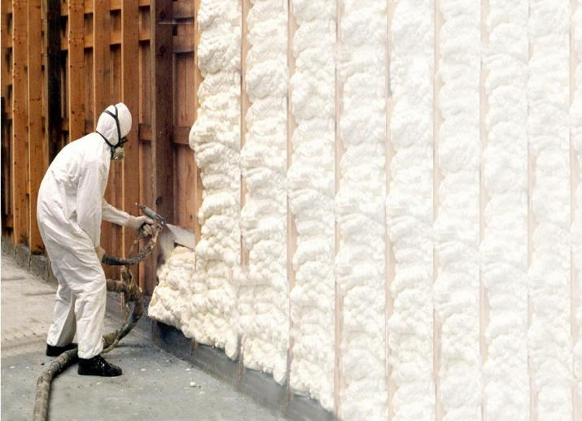

**Carpeting**

**While it may not be formaldehyde that most people expect to be the primary culprit here, carpets can release many other volatile organic compounds (VOCs). The manufacturing process of using mostly synthetic materials and having to heat up the carpet to high temperatures in order to apply dyes and adhesives will inevitably introduce a lot of harmful chemicals into your home.**

**Mites:**

### House dust mites are mites found in association with dust in dwellings. They feed on skin flakes from animals, including [humans](https://en.wikipedia.org/wiki/Human), and on some [mold](https://en.wikipedia.org/wiki/Mold). Dust mites are found worldwide, but are found more commonly in humid regions.

The mite's gut contains potent digestive enzymes (notably [Peptidase 1](https://en.wikipedia.org/wiki/Peptidase_1_(mite))) that persist in their feces and are major inducers of allergic reactions such as [wheezing](https://en.wikipedia.org/wiki/Wheeze). The mite's exoskeleton can also contribute to allergic reactions. **Unlike**[**scabies**](https://en.wikipedia.org/wiki/Scabies)**mites or skin follicle mites, house dust mites do not burrow under the skin and are not parasitic.**

**Upholstery** is the work of providing **furniture**, especially seats, with padding, springs, webbing, and fabric or leather covers.

**Molds:**

Molds, like most fungi, break down plant and animal matter in the environment. They can grow almost anywhere there is moisture and organic material such as in soil, on foods and plants, and in people's homes. Molds cause [biodegradation](https://en.wikipedia.org/wiki/Biodegradation) of natural materials, which can be unwanted when it becomes [food spoilage](https://en.wikipedia.org/wiki/Decomposition) or damage to property. They also play important roles in biotechnology and food science in the production of various foods, beverages, [antibiotics](https://en.wikipedia.org/wiki/Antibiotic), pharmaceuticals and [enzymes](https://en.wikipedia.org/wiki/Enzyme).

To reproduce, molds release spores, which can spread through air, water, or on animals. Mold spores are always found in the air we breathe, but extensive mold contamination may cause health problems. Breathing mold can cause allergic and respiratory symptoms. Some diseases of animals and humans can be caused by certain molds: disease may result from allergic sensitivity to mold spores, from growth of [pathogenic](https://en.wikipedia.org/wiki/Pathogen) molds within the body, or from the effects of ingested or inhaled toxic compounds ([**mycotoxins**](https://en.wikipedia.org/wiki/Mycotoxin)) produced by molds. A mycotoxin is a toxic secondary metabolite produced by organisms of the fungus kingdom and is capable of causing disease and death in both humans and other animals.  Acute toxicity includes gastrointestinal symptoms like vomiting and diarrhea, as well as acute liver disease.

Symptoms caused by mold allergy are: watery, itchy eyes; a chronic cough; headaches or migraines; difficulty breathing; rashes; tiredness; sinus problems; nasal blockage and frequent sneezing.

**Lead:**

Lead is a chemical element with the symbol Pb and atomic number 82. It is a heavy metal that is denser than most common materials. Lead is soft and malleable, and also has a relatively low melting point. When freshly cut, lead is silvery with a hint of blue; it tarnishes to a dull gray color when exposed to air.

Lead is still widely used for car batteries, pigments, ammunition, cable sheathing, weights for lifting, weight belts for diving, lead crystal glass, radiation protection and in some solders.

Lead can be released directly into the air, as suspended particles. Historic major sources of lead air emissions were motor vehicles and industrial sources. Exposure to high levels of lead is toxic to plants and animals. It is usually found in the environment in soils or sediments. Lead is a cumulative poison which affects the central nervous system.

**Ozone:**

“Ground level ozone, or tropospheric ozone, is primarily created when emissions of **volatile organic compounds (VOCs)** as well as **nitrogen oxides interact** in the atmosphere **in the presence of sunlight and heat**.”  “Volatile organic compounds are dangerous by themselves, and so are nitrogen oxides, but when these two air pollutants are exposed to sunlight they turn into tropospheric ozone.” Ozone can also be formed in the home by some types of air cleaning products. These products are intended to neutralize harmful indoor air pollutants but can emit ozone by doing so, which is itself harmful.

**Photocopiers emit ozone** into the air, which is the main reason you should not sit next to a **copier** at work. Ozone is usually produced during charging and discharging of the drum and paper. It is also produced from ultraviolet emission from the photocopier lamp. So, commercial operations of **photocopy machines** are highly exposed to the sweet-smelling pollutant, Ozone.

When inhaled, **ozone** can damage the lungs. Relatively low amounts of **ozone** can cause chest pain, coughing, shortness of breath and, throat irritation. It may also worsen chronic respiratory diseases such as asthma as well as compromise the ability **of the body** to fight respiratory infections.

**Brominated flame retardants** (BFRs) are mixtures of man-made chemicals that are added to a wide variety of products, including for industrial use, to make them less flammable. They are used commonly in plastics, textiles and electrical/electronic equipment.

**Polycyclic aromatic hydrocarbons** are [hydrocarbons](https://en.wikipedia.org/wiki/Hydrocarbon)—[organic compounds](https://en.wikipedia.org/wiki/Organic_compound) containing only carbon and hydrogen—that are composed of multiple [aromatic rings](https://en.wikipedia.org/wiki/Aromatic_ring). Some PAHs are manufactured. These pure PAHs usually exist as colorless, white, or pale yellow-green solids. PAHs are found in coal tar, crude oil, creosote, and roofing tar, but a few are used in medicines or to make dyes, plastics, and pesticides.

Polycyclic aromatic hydrocarbons (PAHs) are made whenever substances are burned. PAHs are released from burning coal, oil, gasoline, trash, tobacco, and wood. High-temperature cooking, such as grilling, will form PAHs in meat and other foods. PAHs can be released naturally from forest fires and volcanoes.

* Air – cigarette and secondhand smoke, vehicle exhaust, and emissions from fossil fuels, forest fires, and volcanoes
* Food – grilled meats
* Water – contaminated by emissions

Exposure to some PAHs can cause:

* Irritation of the eyes and breathing passages
* Cancer

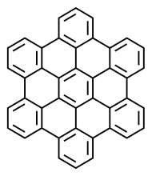

**Etching** is traditionally the process of using strong acid or mordant to cut into the unprotected parts of a metal surface to create a design in intaglio (incised) in the metal.

**Computer As Source Of Air Pollution:**

[Nitrogen](https://en.wikipedia.org/wiki/Nitrogen)-[fluorine](https://en.wikipedia.org/wiki/Fluorine) compound is a colorless, nonflammable gas with a slightly musty odor. NF3 compound is used in manufacture of semiconductors as a cleaning and etching agent. Nitrogen trifluoride is one of several gases used during the manufacture of liquid crystal flat-panel displays, thin-film photovoltaic cells and microcircuits.

Also used during manufacturing process of flat panel televisions, computer displays, microcircuits, solar panels.

Emissions of **NF3** were thought to be so low that the gas was not considered to be a significant potential contributor to global warming. But after research it was found that, the gas is **17,000** times more potent as a global warming agent than a similar mass of carbon dioxide. It survives in the atmosphere about **five** times longer than carbon dioxide.

**Flues**: A duct for smoke and waste gases produced by a fire, a gas heater, a power station, or other fuel-burning installation.

**Improved stoves with flues:**

The food is cooked at the top where that place is heated. So, no smoke out in room.

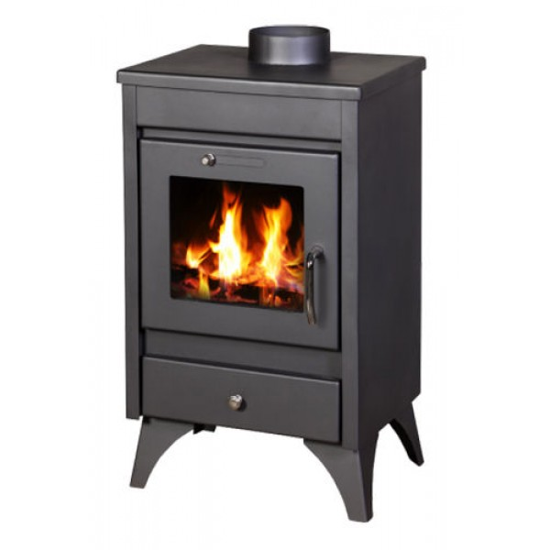

**Improved biomass stoves without flues:**

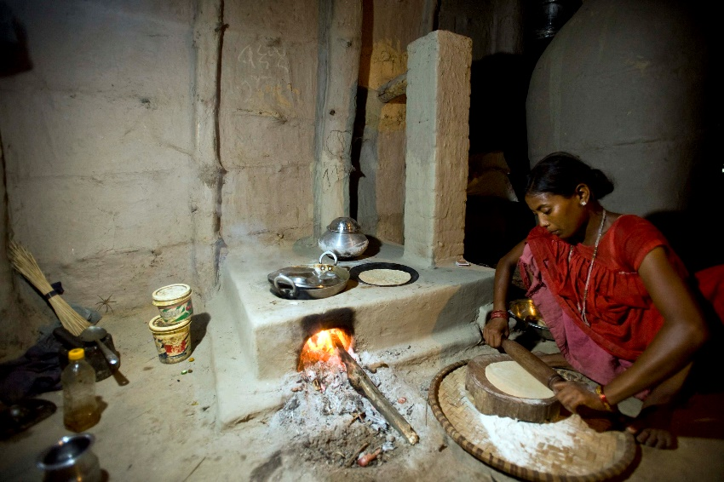

**Briquettes:**

A briquette is a compressed block of coal dust or other combustible biomass material ((e.g. charcoal, sawdust, wood chips, peat, or paper) used for fuel and kindling to start a fire. The term derives from the French word brique, meaning brick.

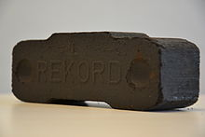

Coal briquettes

**Pellets:** (a small, rounded, compressed mass of a substance)

Pellet fuels are biofuels made from compressed organic matter or biomass. Pellets can be made from any one of five general categories of biomass: industrial waste and co-products, food waste, agricultural residues, energy crops, and virgin lumber (saw dust).

Pellets are extremely dense and can be produced with a low moisture content (below 10%) that allows them to be burned with a very high combustion [efficiency](https://en.wikipedia.org/wiki/Efficiency).

Further, their regular geometry and small size allow automatic feeding with very fine calibration.

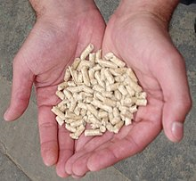

Wood pellets

**Producer gas:**

Producer gas, mixture of flammable gases (principally carbon monoxide and hydrogen) and nonflammable gases (mainly nitrogen and carbon dioxide) made by the partial combustion of carbonaceous substances, usually coal, in an atmosphere of air and steam.

**Retained heat cooker:**

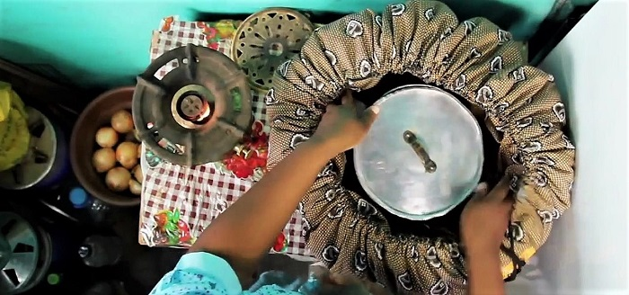

‘Retained Heat Cooker’ is a standalone, non-electric insulated bag designed to reduce the amount of fuel required to cook food. Instead of being placed on a stove for the entire duration, food is heated to a boiling temperature and transferred to the cooker. It uses the principle of thermal insulation to continue the cooking process without requiring any additional heat. Retained heat cooker provides the possibility of smooth cooking by retaining the heat within the enclosed space using thermal insulation. [It reduces the emission of CO2and fuel consumption](https://www.giz.de/de/downloads/giz2016-en-retained-heat-cooker.pdf) that will be creating a positive impact in our environment.

Here two layers of fabric are sewn according to desired shape. For getting thermal insulation properties; polystyrene beads from EPS are used. Recycled materials such as wool blankets, old sweaters, newspaper can be used as good insulation material for fabricating this bag.

**Ventilation** is the intentional introduction of outdoor air into a space and is mainly used to control indoor air quality by diluting and displacing indoor pollutants; it can also be used for purposes of thermal comfort or dehumidification.

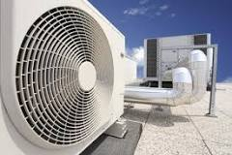

**Hoods:**

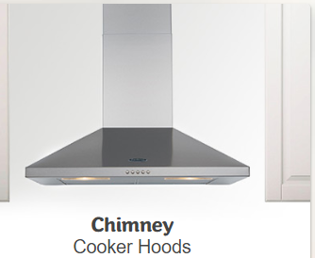

**Fireplace**: A fireplace or hearth is a structure made of brick, stone or metal designed to contain a [fire](https://en.wikipedia.org/wiki/Fire). Fireplaces are used for the relaxing ambiance they create and for heating a room. Modern fireplaces vary in heat efficiency, depending on the design.

A place for a domestic fire, especially a grate or hearth at the base of a chimney.

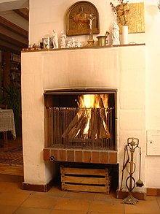

**Eaves:**

The eaves are the edges of the roof which overhang the face of a wall and, normally, project beyond the side of a building.

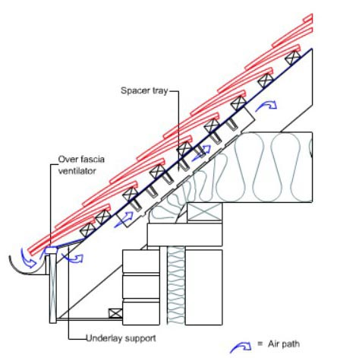

**Waist:**

The waist is the part of the abdomen between the rib cage and hips. On people with slim bodies, the waist is the narrowest part of the torso.

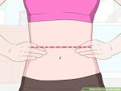 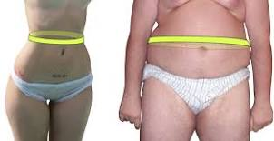

Fumes:

[Strong](https://dictionary.cambridge.org/dictionary/english/strong), [unpleasant](https://dictionary.cambridge.org/dictionary/english/unpleasant), and sometimes [dangerous](https://dictionary.cambridge.org/dictionary/english/dangerous) [gas](https://dictionary.cambridge.org/dictionary/english/gas) or [smoke](https://dictionary.cambridge.org/dictionary/english/smoke). E.g. [*exhaust*](https://dictionary.cambridge.org/dictionary/english/exhaust)*fumes*, *Petrol fumes,* [*cigar*](https://dictionary.cambridge.org/dictionary/english/cigar)*fumes.*

Mist:

a cloud of tiny water droplets suspended in the atmosphere at or near the earth's surface that limits visibility (to a lesser extent than fog)

Secondary Pollutant:

Examples of a secondary pollutant include ozone, which is formed when hydrocarbons (HC) and **nitrogen oxides** (NOx) combine in the presence of sunlight; NO2, which is formed as NO combines with oxygen in the air. **Examples of primary pollutants** include sulfur dioxide (SO2), carbon monoxide (CO), nitrogen oxides (NOX), and particulate matter (PM). **Examples** of **secondary pollutants** include photochemical oxidants (ozone, nitrogen dioxide, sulfur trioxide) and **secondary** particulate matter.

Photochemical smog:

When ultraviolet light from the sun reacts with nitrogen oxides in the atmosphere, photochemical smog is produced. Brown haze is commonly seen, and is most prominent during the morning and afternoon, especially in densely populated, warm cities.

It is a result of the interactions of primary pollutants with other [molecules](https://energyeducation.ca/encyclopedia/Molecule) in the [air](https://energyeducation.ca/encyclopedia/Air) such as [molecular oxygen](https://energyeducation.ca/encyclopedia/Molecular_oxygen), [water](https://energyeducation.ca/encyclopedia/Water) and [hydrocarbons](https://energyeducation.ca/encyclopedia/Hydrocarbon). These combine to form yellow clouds that are harmful to humans.

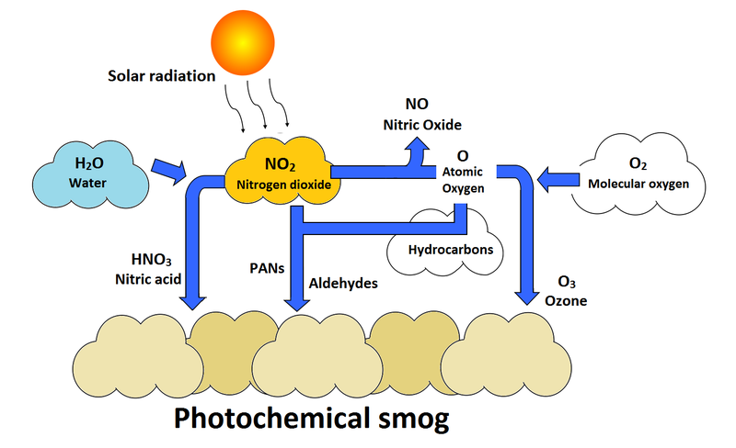

Figure 2. Photochemical smog formation; sunlight reacts with NO2 which then interacts with other molecules in the air to form smog.

**Effluents:** Liquid waste or sewage discharged into a river or the sea.

**Gaseous effluents:** Odors from industrial facilities are a mixture of a large list of simple and complex volatile, organic and inorganic compounds that produce a physiological response in the pituitary gland since, even at trace level concentrations, most VOCs are malodorous and have very low odor thresholds.

**Catalytic incinerators:**

Catalytic incinerators are used to destroy gaseous pollutants such as VOCs. A catalytic incinerator permits the incineration reactions to occur more quickly and at reduced temperatures. The best metal catalysts are platinum and palladium. However, less expensive oxides of copper, chromium, vanadium, nickel and cobalt can also be used. The catalyst is in the form of porous pellets, honeycombs or wire mesh designed to present a large surface area to the gas stream.

In a reversible-flow incinerator the airstream is preheated as it passes through a hot ceramic bed. When the gas reaches the catalytic surfaces, the organic compounds are oxidised and the gas temperature rises dramatically. The gas then passes through a second ceramic bed, which is cooler than the gas. Heat from the gas is absorbed by this bed and the cooled gas is vented to the atmosphere. The temperature of the second ceramic bed rises until it is no longer able to absorb heat from the gas. At this point a changeover valve operates and the direction of the gas flow is reversed and the process continues in the reverse direction.

Application

As with thermal oxidation, the aim of catalytic incineration is to convert toxic or ozone-forming organic pollutants into carbon dioxide and water. Catalytic incinerators are used to remove VOCs such as solvents from printing and paint-spraying processes. There are similar applications in the food, tobacco, metal and chemical industries.

Catalytic incinerators are not suitable for emissions containing particulate or polymeric material as these may block the fine catalytic structure.

**Petrochemical Plant:**

Petrochemical plants convert natural resources such as crude oil, natural gas, ores and minerals into products for a wide range of applications. They produce many important building blocks for industry processes, including ethylene, propylene, butadiene, and aromatics.

**Smokehouse:** A smokehouse is a building where meat or fish is [cured](https://en.wikipedia.org/wiki/Curing_(food_preservation)) with [smoke](https://en.wikipedia.org/wiki/Smoking_(cooking)). The finished product might be stored in the building, sometimes for a year or more. Traditionally, a smokehouse is a small enclosed outbuilding often with a vent, a single entrance, no windows, and frequently has a [gabled](https://en.wikipedia.org/wiki/Gabled_roof) or pyramid-style roof.

**Rendering:**

Rendering is a process that converts waste animal tissue into stable, usable materials. Rendering can refer to any processing of animal products into more useful materials, or, more narrowly, to the rendering of whole animal fatty tissue into purified fats.

**Paint Baking Oven:**

Paint Baking Oven, also referred to as Dryers or Paint Curing Ovens or Paint Drying Ovens removes the moisture from water-based coatings and adhesives. Paint Drying Ovens are also removes water from the surface or interior of products with the help of thermostatic controls in case of electrical heating and temperature controllers operating solenoid valves in case of steam, gas and oil heating. A Paint Drying Oven dries the paint through the heated air that is re circulated in the Oven. This is generally done by having a heating chamber where air is heated and the heated air is circulated inside the Paint Drying Oven chambers by means of fans.

A **molecular sieve** is a material with pores (very small holes) of uniform size. These pore diameters are similar in size to small molecules, and thus large molecules cannot enter or be [adsorbed](https://en.wikipedia.org/wiki/Adsorbed), while smaller molecules can.

**Chemical affinity** is the electronic property by which dissimilar [chemical species](https://en.wikipedia.org/wiki/Chemical_species) are capable of forming [chemical compounds](https://en.wikipedia.org/wiki/Chemical_compounds).[[1]](https://en.wikipedia.org/wiki/Chemical_affinity#cite_note-Chisholm_1911_loc=Affinity,_Chemical-1) Chemical affinity can also refer to the tendency of an [atom](https://en.wikipedia.org/wiki/Atom) or compound to combine by [chemical reaction](https://en.wikipedia.org/wiki/Chemical_reaction) with atoms or compounds of unlike composition.

**Sorbent:**

A sorbent is a material used to [absorb](https://en.wikipedia.org/wiki/Absorption_(chemistry)) or [adsorb](https://en.wikipedia.org/wiki/Adsorption) liquids or gases. Examples include:

* A material similar to [molecular sieve](https://en.wikipedia.org/wiki/Molecular_sieve) material, which acts by adsorption (attracting molecules to its surface). It has a large internal [surface area](https://en.wikipedia.org/wiki/Surface_area) and good [thermal conductivity](https://en.wikipedia.org/wiki/Thermal_conductivity).
* Materials used to absorb other materials due to their high [affinity](https://en.wikipedia.org/wiki/Chemical_affinity) for doing so.

**Decantation:**

Decantation is a process for the separation of mixtures of immiscible liquids or of a liquid and a solid mixture such as a suspension. The layer closer to the top of the container—the less [dense](https://en.wikipedia.org/wiki/Density) of the two liquids, or the liquid from which the [precipitate](https://en.wikipedia.org/wiki/Precipitation_(chemistry)) or [sediment](https://en.wikipedia.org/wiki/Sedimentation) has settled out—is poured off, leaving the other component or the more dense liquid of the mixture behind.

**Incineration:**

Incineration is a waste treatment process that involves the combustion of organic substances contained in waste materials. Incineration and other high-temperature waste treatment systems are described as "thermal treatment". Incineration of waste materials converts the waste into ash, flue gas and heat.

**Matted:** Covered with a dense growth or a tangled mass: a garden matted with weeds. formed into a mat; **entangled** in a thick mass

**Felt** is a [textile](https://en.wikipedia.org/wiki/Textile) material that is produced by matting, condensing and pressing [fibers](https://en.wikipedia.org/wiki/Fibers) together. Felt can be made of natural fibers such as [wool](https://en.wikipedia.org/wiki/Wool) or animal fur, or from [synthetic fibers](https://en.wikipedia.org/wiki/Synthetic_fibers) such as [petroleum](https://en.wikipedia.org/wiki/Petroleum)-based [acrylic](https://en.wikipedia.org/wiki/Acrylic_fiber) or [acrylonitrile](https://en.wikipedia.org/wiki/Acrylonitrile) or [wood pulp](https://en.wikipedia.org/wiki/Wood_pulp)-based [rayon](https://en.wikipedia.org/wiki/Rayon). Blended fibers are also common

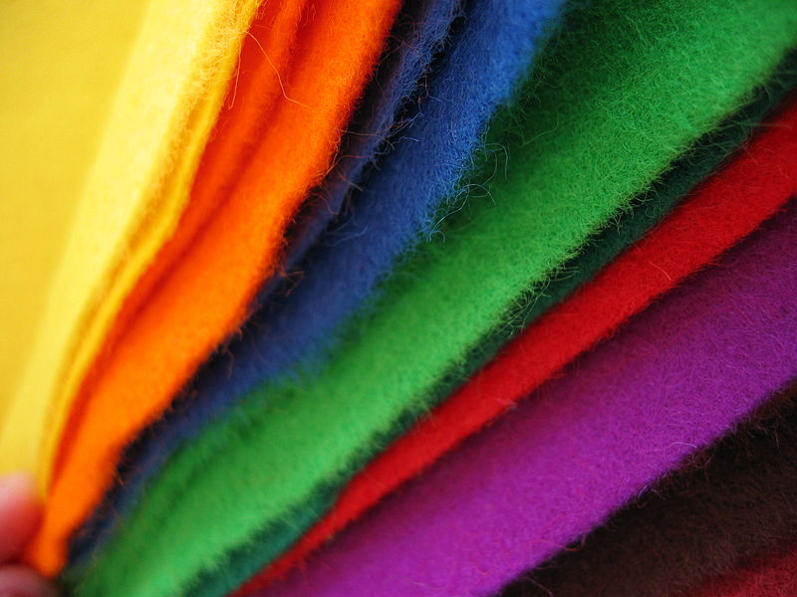

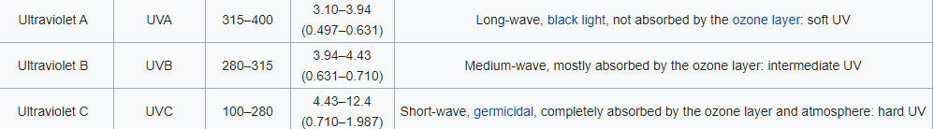

**Halogens:**

The **halogens** are a group in the periodic table consisting of five chemically related elements: fluorine (F), chlorine (Cl), bromine (Br), iodine (I), and astatine (At).

**Halon:**

any of a number of unreactive gaseous compounds of carbon with bromine and other halogens, used in fire extinguishers, but now known to damage the ozone layer.

Halons are low-toxicity, chemically stable compounds that have been used for fire and explosion protection from early in the last century. Halon has proven to be an extremely effective fire suppressant. Halon is clean (i.e., leaves no residue) and is remarkably safe for human exposure.

**Degreasing agents**:

Degreasing agents are a type of cleaning product used in several industries for lifting grease, oil, fats, or other contaminants from the surface of an object. Solvents are a common choice for removing unwanted contaminants from difficult to clean surfaces.

**Convention:** An agreement between states covering particular matters, especially one less formal than a treaty.

**Secretariat:** A permanent administrative office or department, especially a governmental one.

**Convention Secretariat** is a global authority concerning the implementation of the WHO FCTC.  It also works to promote the Protocol to Eliminate Illicit Trade in Tobacco Products. **FCTC=Framework Convention on Tobacco Control**

**Terminal Phase out management Plan:**

CFC-using entities to be reduced efficiently and effectively. Phase out CFC use through the adoption of appropriate non-ozone depleting substances (ODS) technologies and related measures, allowing the country to achieve complete phase-out of CFCs.

**Tanning** is the process of treating skins and hides of animals to produce leather. A tannery is the place where the skins are processed.

**Eutrophication:**

Eutrophication, or hypertrophication, is when a body of water becomes overly enriched with minerals and nutrients which induce excessive growth of algae. This process may result in oxygen depletion of the water body

**Agricultural runoff:**

Agricultural Runoff is water sent from farm fields due to irrigation, rain, or melted snow. This runoff water can contain fertilizers, pesticides, animal waste, or soil particles, which can enter and contaminate sources of drinking water. Agricultural Runoff has been a growing issue for lakes and rivers.

**Anthropogenic:**

Anthropogenic means of, relating to, or resulting from the influence of human beings on nature. Anthropogenic emissions of pollutants have significantly and rapidly altered the function of ecosystems, including our own, however these pollutants are being produced because of our need for energy.

**Phytoplankton**:

Phytoplankton are microscopic marine algae. Phytoplankton is the base of several aquatic food webs, the primary producers. In a balanced ecosystem, they provide food for a wide range of sea creatures including whales, shrimp, snails, and jellyfish.

**Zooplankton**:

Zooplankton (pictured below) are a type of heterotrophic plankton that range from microscopic organisms to large [species](https://biologydictionary.net/species/), such as jellyfish.

**Municipal wastewater:**

Municipal wastewater is a type of wastewater that is produced by a community of people. It is characterized by volume or rate of flow, physical condition, chemical and toxic constituents, and its bacteriologic status.

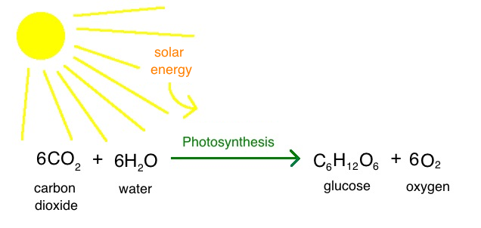

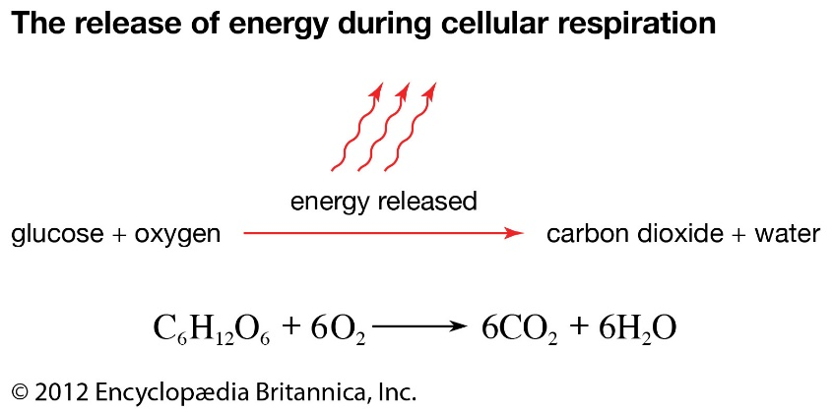

**Sludge:** Thick, soft, wet mud or a similar viscous mixture of liquid and solid components, especially the product of an industrial or refining process.

**Lagoon**:

A **lagoon** is a shallow body of water separated from a larger body of water by barrier islands or reefs.

**Turbidity:**

Turbidity is a measure of the degree to which the water loses its transparency due to the presence of suspended particulates. The more total suspended solids in the water, the murkier it seems and the higher the turbidity. Turbidity is considered as a good measure of the quality of water.

Turbidity is the cloudiness or haziness of a fluid caused by large numbers of individual particles that are generally invisible to the naked eye, similar to smoke in air. The measurement of turbidity is a key test of water quality.

# **How do we measure turbidity?**

Turbidity is measured in NTU: Nephelometric Turbidity Units. The instrument used for measuring it is called nephelometer or turbidimeter, which measures the intensity of light scattered at 90 degrees as a beam of light passes through a water sample.

The unit used in the ancient times was JTU (Jackson Turbidity Units), measured with the Jackson candle turbidimeter. This unit is no longer in standard use.

In lakes the turbidity is measured with a secchi disk (in the picture).

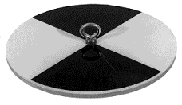

This is a black and white disk that is dropped in the water attached to a rope.

The depth that the disk reaches before it disappears from sight is recorded.

This provides an estimation of the turbidity level in the lake.

A turbidity measurement could be used to provide an estimation of the TSS (Total Suspended Solids) concentration, which is otherwise a tedious and difficult parameter to measure.

The WHO (World Health Organization), establishes that the **turbidity** of drinking water shouldn't be more than **5 NTU**, and should ideally be below 1 **NTU**.

**True Color Unit (TCU):**

The colour of the water can indicate the degree of organic matter that may be present. The Otonabee River has ‘tea’ coloured water that indicates the presence of humic substances. Humic substances are the end product of decaying organic matter and most likely contain tannin (complex organic compound found naturally in soil and in certain tree barks) and lignin (natural compound common in woody plants and trees). These compounds are part of a natural group of organic substances in soil, produced by decaying vegetation.

Levels of colour above 15 TCU can be detected in a glass of water by most people. The aesthetic objective for colour in treated water is 5 True Colour Units (TCU’s). In 2013, the average raw water colour was 14 TCU (was 11 TCU in 2012)

**TDS stands for total dissolved solids:**

Represents the total concentration of dissolved substances in **water**. Common inorganic salts that can be found in **water** include calcium, magnesium, potassium and sodium, which are all cations, and carbonates, nitrates, bicarbonates, chlorides and sulfates, which are all anions

**Carbonaceous:** Relating to, containing, or composed of [carbon](https://www.merriam-webster.com/dictionary/carbon) or rich in carbon

**Nitrogenous**: Containing nitrogen in chemical combination.

**Grit:** Small loose particles of stone or sand.

**Aeration:** Aeration is the process by which air is circulated through, mixed with or dissolved in a liquid.

**Pulp:** Crush into a soft, wet, shapeless mass.

**Sewage:** Sewage is the waste matter carried off by sewer drains and pipes.

**NDWQS: [Nepal's Drinking Water Quality Standards](http://www.wepa-db.net/policies/law/nepal/st01.htm)**

<http://www.wepa-db.net/policies/law/nepal/st01.htm>

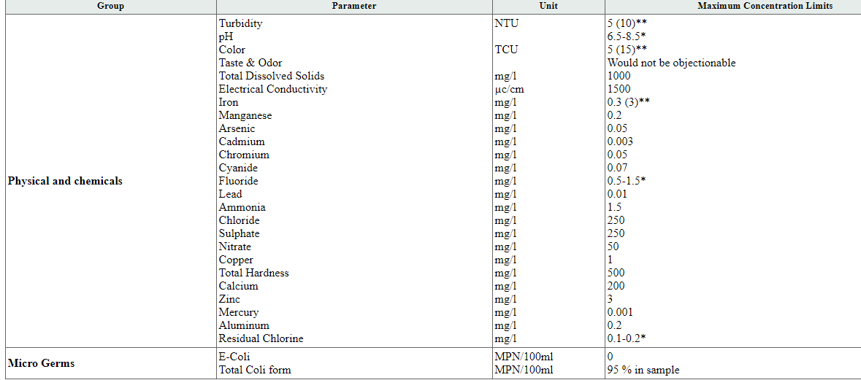

**Coagulation:**

In water treatment, coagulation [flocculation](https://en.wikipedia.org/wiki/Flocculation) involves the addition of compounds that promote the clumping of fines into larger floc so that they can be more easily separated from the water. Coagulation is a chemical process that involves neutralization of charge whereas [flocculation](https://en.wikipedia.org/wiki/Flocculation) is a physical process and does not involve neutralization of charge. The coagulation-flocculation process can be used as a preliminary or intermediary step between other water or [wastewater treatment](https://en.wikipedia.org/wiki/Wastewater_treatment) processes like [filtration](https://en.wikipedia.org/wiki/Filtration) and [sedimentation](https://en.wikipedia.org/wiki/Sedimentation). Iron and aluminium salts are the most widely used [coagulants](https://en.wikipedia.org/wiki/Flocculation) but salts of other metals such as [titanium](https://en.wikipedia.org/wiki/Titanium) and [zirconium](https://en.wikipedia.org/wiki/Zirconium) have been found to be highly effective as well.

Coagulants neutralize the negative electrical charge on particles, which destabilizes the forces keeping colloids apart. Water treatment coagulants are comprised of positively charged molecules that, when added to the water and mixed, accomplish this charge neutralization. Once the repulsive charges have been neutralized, [van der Waals force](https://en.wikipedia.org/wiki/Van_der_Waals_force) will cause the particles to cling together (agglomerate) and form micro floc.

The most common used coagulant is [alum](https://en.wikipedia.org/wiki/Alum), Al2(SO4)3 • 14 H2O.

The chemical reaction involved:

Al2(SO4)3 • 14 H2O → 2 Al(OH)3(s) + 6 H+ + 3 SO42- + 8 H2O

**Flocculant:**

According to the [IUPAC](https://en.wikipedia.org/wiki/IUPAC) definition, flocculation is "a process of contact and adhesion whereby the particles of a dispersion form larger-size clusters". Basically, coagulation is a process of addition of coagulant to destabilize a stabilized charged particle. Meanwhile, flocculation is a mixing technique that promotes agglomeration and assists in the settling of particles. During flocculation, gentle mixing accelerates the rate of particle collision, and the destabilized particles are further aggregated and enmeshed into larger precipitates. Flocculation is affected by several parameters, including mixing speeds, mixing intensity, and mixing time. The product of the mixing intensity and mixing time is used to describe flocculation processes.

Flocculants gather the destabilized particles together and cause them to agglomerate and drop out of solution. Examples of ChemTreat flocculants include low-, medium-, and high-molecular weight polymers. The aluminum coagulants include aluminum sulfate, aluminum chloride and sodium aluminate. The iron coagulants include ferric sulfate, ferrous sulfate, ferric chloride and ferric chloride sulfate.

**Harmony:** The combination of simultaneously sounded musical notes to produce a pleasing effect

**Acoustic impedance:** are measures of the opposition that a system presents to the acoustic flow. when a sound wave strikes an interface between the two mediums, it encounters an impedance (resistance to sound in two medium) mismatch. As a result, some of the wave reflects while some is transmitted into the second medium.

 In the case of the well-known [bell-in-vacuum experiment](https://www.britannica.com/science/bell-in-vacuum-experiment), the impedance mismatches between the bell and the air and between the air and the jar result in very little transmission of sound when the air is at [low pressure](https://www.britannica.com/science/cyclone-meteorology).

The [efficiency](https://www.merriam-webster.com/dictionary/efficiency) with which a sound source radiates sound is [enhanced](https://www.merriam-webster.com/dictionary/enhanced) by reducing the impedance mismatch between the source and the outside air. For example, if a [tuning fork](https://www.britannica.com/technology/tuning-fork) is struck and held in the air, it will be nearly inaudible because of the inability of the [vibrations](https://www.britannica.com/science/vibration) of the tuning fork to radiate efficiently to the air. Touching the tuning fork to a wooden plate such as a tabletop will [enhance](https://www.merriam-webster.com/dictionary/enhance) the sound by providing better coupling between the vibrating tuning fork and the air.

This principle is used in the violin and the piano, in which the vibrations of the strings are transferred first to the back and belly of the violin or to the piano’s sounding board, and then to the air.

**Refuse** includes garbage and rubbish. Garbage is mostly decomposable food **waste**; rubbish is mostly dry material such as glass, paper, cloth, or wood.

**Sludge:** Thick, soft, wet mud or a similar viscous mixture of liquid and solid components, especially the product of an industrial or refining process.

**Bulky waste:** Bulky waste or bulky refuse is a technical term taken from [waste management](https://en.wikipedia.org/wiki/Waste_management) to describe [waste types](https://en.wikipedia.org/wiki/Waste_types) that are too large to be accepted by the regular [waste collection](https://en.wikipedia.org/wiki/Waste_collection).

Bulky waste items include discarded furniture ([couches](https://en.wikipedia.org/wiki/Couch), [recliners](https://en.wikipedia.org/wiki/Recliner), [tables](https://en.wikipedia.org/wiki/Table_(furniture))), large appliances ([refrigerators](https://en.wikipedia.org/wiki/Refrigerator), [ovens](https://en.wikipedia.org/wiki/Oven), [TVs](https://en.wikipedia.org/wiki/TV)), and plumbing fixtures ([bathtubs](https://en.wikipedia.org/wiki/Bathtub), [toilets](https://en.wikipedia.org/wiki/Toilet), sinks). A large amount (30-60%, depending on area) of bulky waste is picked up by scavengers before it is collected. Branches, brush, logs and other [green waste](https://en.wikipedia.org/wiki/Green_waste) are also categorized as bulky waste, although they may be collected separately for shredding and/or [composting](https://en.wikipedia.org/wiki/Composting).

**Pathological waste**: Pathological waste is a subcategory of biohazardous waste. It typically originates from surgical procedures or research that involves removal of organs, tissues or body parts. Pathological waste can be human or animal.

**Domestic Waste:** Domestic sewage means the water-carried human wastes from residences, buildings, industrial establishments or other places. Domestic sewage means untreated sanitary wastes that pass through a sewer system.

**Sewage, or domestic/municipal wastewater, is a type of wastewater that is produced by a community of people.**

**Discharge: Allow (a liquid, gas, or other substance) to flow out from where it has been confined.**

**Resident:** living somewhere on a long-term basis.

**Residential waste: Residential waste** means any waste material, including garbage, trash and refuse, derived from households. Households include single and multiple residences, hotels and motels, bunkhouses, ranger stations, crew quarters, campgrounds, picnic grounds and day-use recreation areas. Residential wastes do not include sanitary waste in septic tanks (septage), that is regulated by other state agencies.

**Institutional Waste:**

Institutional Waste is Waste produced from institutions such as schools, hospitals, or prisons. These include Waste not typically found in households but also hazardous wastes in some circumstances.

**Commercial waste:**

Commercial waste consists of waste from premises used mainly for the purposes of a trade or business or for the purpose of sport, recreation, education or entertainment, but excluding household, agricultural or industrial waste.

**Dwelling:** A house, flat, or other place of residence.

**Site:** An area of ground on which a town, building, or monument is constructed.

**Multiple tray chamber**

**Municipal waste water**

**Oxygen sag curve**

**Detail of waste water treatment plant.**